Dillon Grow

Natalie Ortiz

Megan Rose

Brice Maynard

**COVID-19**

We chose to do a project around COVID-19 as its impacts have affected everyone in the world. There is ample data that has been provided which would make charting and analyzing by state an accessible task. There will be a dropdown to select by state which will update a table with positive cases, negative cases, hospitalized count, etc. We will also show a timeseries of cases for the selected state. There will be a chart to show the Top 10 States with the most cases. A bar chart will be incorporated to show testing results: Positive v Negative and overall. We are looking into using verge3d.

Dataset - <https://covidtracking.com/api>

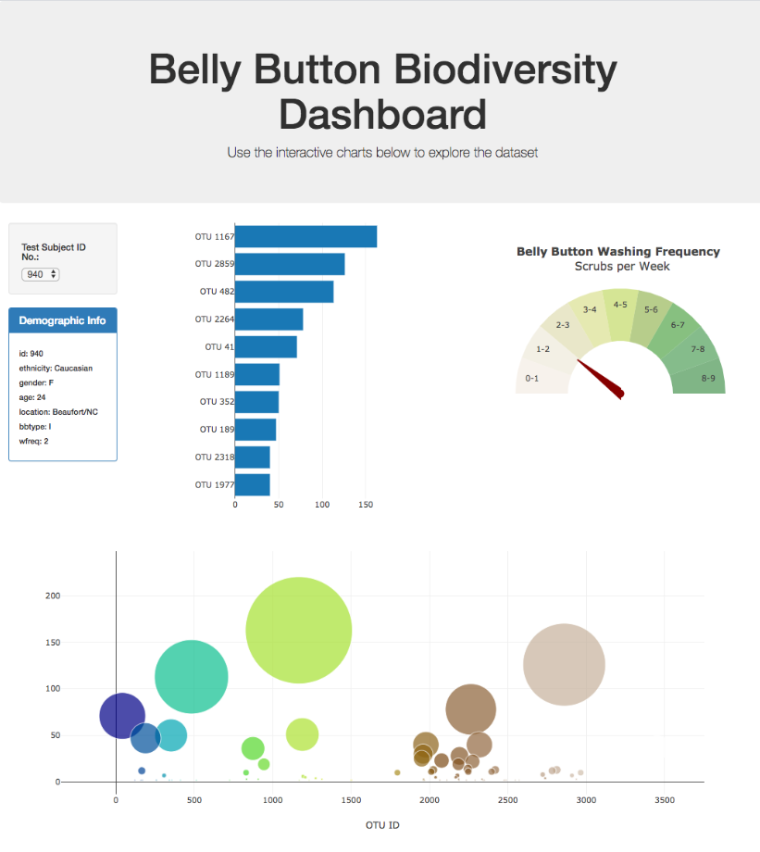

<https://github.com/bricemaynard/Project2.git>